**TO DO QUERIES ON COMPANY DATABASE**

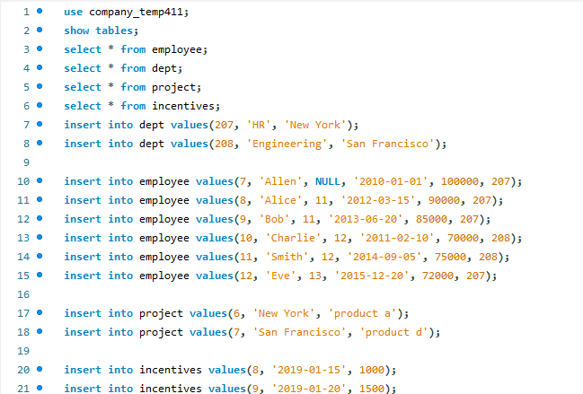

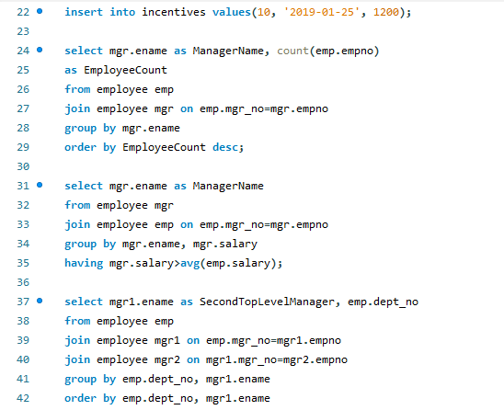

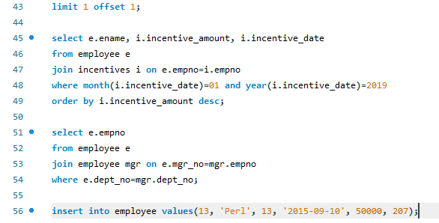

Queries:

select mgr.ename as ManagerName, count(emp.empno)

as EmployeeCount

from employee emp

join employee mgr on emp.mgr_no=mgr.empno

group by mgr.ename

order by EmployeeCount desc;

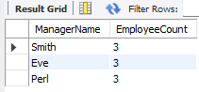

select mgr.ename as ManagerName

from employee mgr

join employee emp on emp.mgr_no=mgr.empno

group by mgr.ename, mgr.salary

having mgr.salary>avg(emp.salary);

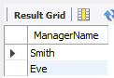

select mgr1.ename as SecondTopLevelManager, emp.dept_no

from employee emp

join employee mgr1 on emp.mgr_no=mgr1.empno

join employee mgr2 on mgr1.mgr_no=mgr2.empno

group by emp.dept_no, mgr1.ename

order by emp.dept_no, mgr1.ename

limit 1 offset 1;

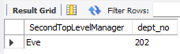

select e.ename, i.incentive_amount, i.incentive_date

from employee e

join incentives i on e.empno=i.empno

where month(i.incentive_date)=01 and year(i.incentive_date)=2019

order by i.incentive_amount desc;

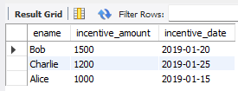

select e.empno

from employee e

join employee mgr on e.mgr_no=mgr.empno

where e.dept_no=mgr.dept_no;

